Name: ______________________________________________ Due Date: February 18
Literature Evaluation-Fiction Book 7
Title: ________________________________________________ Level: ______ Sticky Notes or Reading Notes Attached: _________
These need to be turned in
Author: ____________________________________ Genre: ____________________
On a separate piece of paper, please write out the answers to the following prompts.
- Compare and Contrast two or more settings, characters, or events in the book (pick one and circle the one you are doing).

- Compare and contrast the theme of this book to another book in the same genre (provide evidence).
Please make sure you are writing with fifth grade quality. There should be capitalization and punctuation throughout the piece. There should be at least a paragraph (8-10 sentences) for each section. Remember to use phrases like:
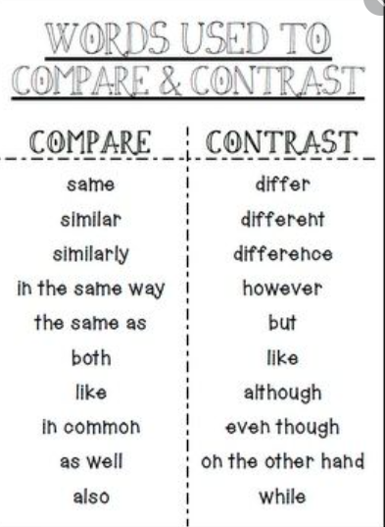
When you are done writing, please go back and highlight any compare and contrast words you used.

Assessment Rubric
4 Met Standard | 3 Consistent progress toward standard | 2 inconsistent progress toward standard | 1 area of concern
Compares, contrasts and analyzes story elements; uses evidence |  |  |  | 4 3 2 1
Compares and contrasts theme in multiple texts of the same genre |  |  |  | 4 3 2 1
Any row not circled was not assessed on this review.

- On the back, draw a picture of the setting of the book. (It could be a map or a single place.)

